**Programming Using C#, Basic Course**

**Assignment 7**

**Online Reservation System (ORS)**

**Padma Priya Duvvuri**

**19840723-5269**

**Description of the objectives:**

Now a day everyone uses Internet for booking movie tickets to buying food. And an effective online reservation form important for the end users to get the benefits of the latest technology.

Online Reservation System (ORS) enables the user to store details of the customers and book the tickets for the chosen type of transportation train, buss or flight on a particular date. The user will be able to add new transportation info. And user can see the timetable of different transportation means.

The end user of this software is reservation personnel in a Travel Agency.

* Only registered customers can book the tickets. And User will be able to add new customers.
* User will be able to see how many seats are left in each of the transportation ( train, buss or flight)
* Only 5 members can be booked on behalf of one customer name.
* There will be rebate in prices depending on age groups. (<2 years, 2-15 years, 15 – 25 yrs, > 25years)
* Customer will be given a reservation number to follow up with if anything changes.
* Only reservations between fixed stations are allowed.

**Class diagram:**

The class diagram shows the relation between class and some of the methods. The attributes and classes may vary at the time of implementation depending on the requirement.

**GUI (supposed)**

|  |  |
| --- | --- |
| **File Customer Transportation Help** | |
| |  | | --- | | Make reservation Reservations Customers |  |  |  | | --- | --- | | From ________(Drop Down)_______ Type of transportation  O Train  To ________(Drop Down)_______ O Buss  O Flight  Date ________________________________  No. of passengers ____________(drop down)____________   |  | | --- | | Continue | | | |

**Class Diagram**

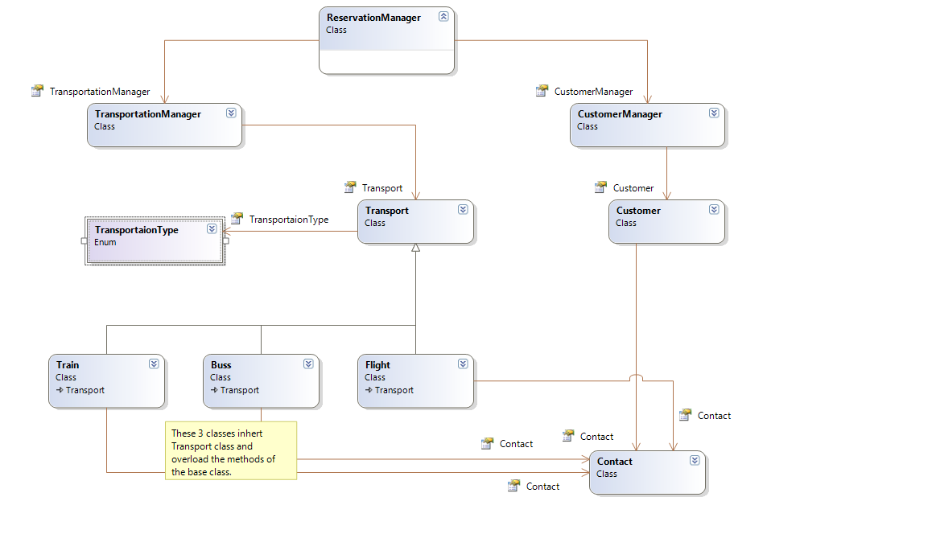

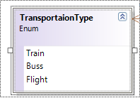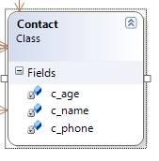

I have provided some attributes and some of the classes.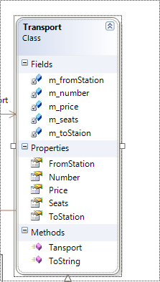 (These are tentative).

**Time schedule:**

The following table shows tentative time schedule, it may vary but the final submission will be done by deadline. As I will be doing this project alone, expected time duration may change.

|  |  |
| --- | --- |
|  | Dates |
| Project Proposal | 3 – 7th December |
| GUI | 10 – 24th December |
| Classes | 10-24th December |
| Testing | 24 – 29th December |
| Submission | 30 or 31st December |

I hope you understand the purpose of my project. Please do let me know if any more information is needed.

Regards,

Padma Priya Duvvuri

Person number: 19840723-5269